**KAMWENDA ENGINEERING ASSOCIATES AND LOGISTICS CONSULTANTS LIMITED**

**2017**



P.O. BOX 50 KAPENGURIA TEL:0739377774/0726549530 EMAIL:kamwendaengineering@gmail.com

**KAPENGURIA KBC, GROUND FLOOR – KAPENGURIA ROAD**

**PHONE: 0739377774 /726549530**

**P.O. BOX 50**

**KAPENGURIA.**



[**kamwendaengieering@gmail.com**](mailto:kamwendaengieering@gmail.com)



[**info@kamwenda.co.ke**](mailto:info@kamwenda.co.ke)



[**WWW.KAMWENDA.CO.KE**](http://www.kamwenda.co.ke/)

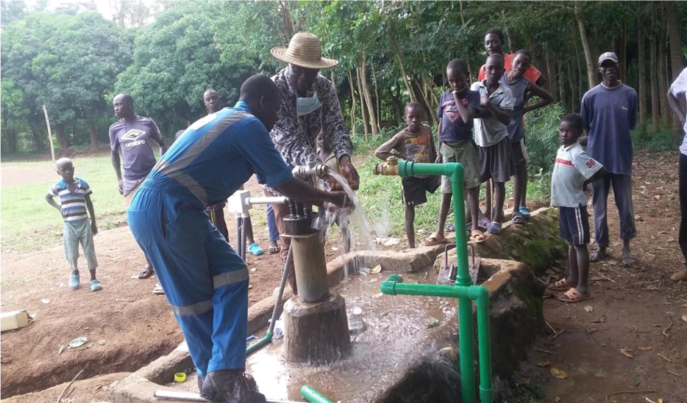

 **Message from the Executive Director**

We take pride in being one of the emerging company dealing with Construction, Engineering & Consultancy related to Environmental Management, Construction Management and Management Consulting in the region having achieved remarkable growth over this year and contributing significantly to the development of the counties. The Company has attained prominence as a leader in the field of construction, engineering & consultancy through competence, competitiveness and timely delivery with highest quality standards and recognized safety performance. We have a long tradition of serving our valued clients to their complete satisfaction through efficient management and excellent workmanship, which we continue to maintain with our untiring efforts.

In an era of advanced technologies and new techniques, we continuously strive for innovation and enhanced efficiency. Offering services spanning a wide range of engineering fields in sewage systems, marine structures, building constructions, power and water, roads & bridges, industrial and civil infrastructure. Kamwenda Engineering Associates and Logistics Consultants (KEALC) is the preferred choice of many clients because of its reliability and commitment to quality and safety. As we look to the years ahead we renew our pledge to remain committed to excellence, keep abreast of changes and innovations, adopt better management and construction techniques and successfully overcome all challenges before us.

I say proudly that, we are found as the preferred and competitive company by our clients and the responsibility of this situation is so important for our company, we along with our experienced staff encouraged to be more successful in coming years. one of the main reasons of our success is the hardworking employees at our head office and self-denying site staffs who work far from their homelands

We believe in building a serious and committed business relationships with our clients and at KEALC, each and every client is important. Our relationships are built on trust and integrity, providing the best services and delivering nothing but excellence. I am proud of the dedicated and ambitious team of professionals at KEALC and would like to thank our clients for putting their trust in us and would ensure them, that we at KEALC, shall continue to ‘outperform targets’ and deliver.

Again, our long-standing experience, openness to future developments and dedication to infrastructure planning as well as micro/macro development, we intend to hold more diversity to embrace repairing and restoring residential and commercial buildings. In all we do, we will, as a team, always be dedicated to providing exceptional and professional approach to constructing exceptional quality projects which meet budget and schedule goals without overruns.

Lastly, our company motto is ‘building the future today’ by using the latest technology to improve the efficiency and cost effectiveness of the project outcome and having value for money.

Yours faithfully,

Rodgers Omondi Kongina.

PhD © MSc/Mph/PMP

**Executive Director**

**Introduction**

Kamwenda Engineering Associates and Logistics Consultants Limitedis incorporated in the Republic of Kenya as a Private Limited LiabilityCompany in the following trades: -

* General construction works
* Water Works & Electrical services
* Security Installations
* General supplies

Our approach to works is the utilization of skilled personnel with practical technical experience in the above mentioned works with special emphasis to quality and on-time project completion.

Our goal is the full satisfaction of our clients, guaranteed by high quality of service and products achieved by the creativity and due diligence of our team members. Frequent interaction with our clients is prioritized to ensure their requirements and expectations are met.

We therefore seek to build a symbiotic business relationship with various entities for related work and attached is our company profile for further perusal. Feel free to contact us and one of our dedicated staff members will be at hand to be of your assistance.

**Who we are**

We are a team of highly motivated, multi skilled and innovative young professionals driven by the desire to transform the society through value addition, quality and efficient service delivery.

We are Construction Company offering services (works) in Construction and Renovations of buildings, Electrical and Water services, and security installations including supplies.

Quality Control and Assurance, Integrity, Technological Advancement, and Professionalism form an integral part of what we observe in cushioning our clients from the tedious and often costly logistics of Construction works thereby focusing on their core businesses.

**Our Services**

1. **General Building Works**

Involving construction of Commercial, Industrial, Residential and Institutional Structures. Including the supply and erection of prefabricated house units to specifications. Using the most modern technology that is presently available, KEALC delivers the best quality in the construction market. While astute in regard to present day construction technology, we are also versatile enough to incorporate locally available materials in the construction process. Consistency with the design specifications is our irrevocable ideal.

We have carried out grading for rural earth roads, stabilized earth works, airstrip rehabilitation and concrete roads. We have just acquired a new concrete paving plant; this will be able to manufacture and supply paving blocks, road kerbs and concrete blocks. Our team envisions manufacturing and supplying of ready mix

concrete for high-rise buildings in three years’ time.

1. **Water works**

This department deals with planning, design and supervision of water, supply, sewerage and irrigation system project. Novel technologies are used in design such as modular design of treatment works, designing for sustainability, ecological sanitation, use of low cost UASB’s in treatment of sewerage etc.

**Our area of expertise includes but not limited to**:

* Water abstractions (river, springs, sinking boreholes, dam intakes)
* Smart metering- new emerging technology in water industry
* pump house with associated piping and electrical installations as per approved designs
* Conveyance (pumping, gravity and their combinations)
* Storage (conventional dams, subsurface, sand dams and ground storage)
* Irrigation systems (gravity surface, drip, micro sprinklers)
* Water shade management/ Leakage studies
* Solid and waste water treatment, re-cycle and disposal
* Ground water resources, quality modelling and management planning
* Integrated river basin management
* Retaining walls, coffer dams,

We have technical expertise that commissions projects involving specialized civil works drainage and water reticulation general plumping and sanitation, fitting of firefighting hydrants, storm drains and sanitary. We have successfully completed projects for large corporations that involve the above works. We support the new trend of smart metering which is quite effective and efficient for the water companies.

1. **Electrical Works**

Involving Design and Development for various electrical Instrumentations for commercial and household uses, Installations and Supplied of electrical items, material selection, procurement and process inventory control. KEALC deals in projects involving installation of Air-conditioning Units, Electrical wiring, supply and Installation of generators, street lighting and metering projects.

1. **General Supplies**

This involves the procurement and transportation of various commodities ranging from sourcing of building materials; Supply of Office stationary, Food stuffs per procurement conditions of Government related and Non-governmental institutions. Large storage areas for imported materials like MDF Boards, Ceiling Boards, Floor & Wall Tiles, Aluminum Sections, and Sanitary Fittings etc.

It is a known fact that fundamental changes are taking place in business today, with flexibility, mobility, how individuals work alone and in teams, redefining the office of the future. Our supplies team has all this mapped out. For complete control, a skilled team will carry out the complete delivery, installation

and after sales support.

1. **Utility Supply and Installation**

This involves the procurement, transportation and installation of utilities and structures like culverts and water tanks. We offer light and bulk transportation of materials and also source for local quality materials like cement, sand, ballast of all sizes, iron sheets etc. KEALC has successfully completed projects involving renovations of large structures, major re-pairs, waterproof. We get your premises covered by installing state of the art CCTV systems and manage them for you.

1. **Manpower and Labor Support**

Warehouse Management, Stock Control, Inventory Services, Blending, Loading & Offloading of trucks, General Depot Logistics. We are supporting man power supply to the construction sites should need be in various construction sites at affordable negotiated rate. We have wide range of man power skills at our disposal who are over experienced in different spheres

1. **Architecture and Design**

KEALC is built on a strong IT background with emphasis on Computer Aided design and simulation expertise in order to postulate top notch architectural designs that stand out from the rest. Our clients have expressed the deepest satisfaction with our Peerless designs roofing refurbishing and walling.

1. **Physical planning and project management**

From subdivision schemes to development plans, part development plans and simulated city models, KEALC’s experts have the technical capacity to match if not surpass your physical planning aspirations. In addition, we also offer competitive packages for services such as preparation of planning briefs, bills of quantities (BOQs) and civil engineering calculations.

1. **Project management for construction projects**

(portfolio management, Occupational Health and Safety & site organization) supervision to ensure quality control & effective construction services delivery are just but highlights of the range of services at KEALC.

**Our Business Strategy & Concept**

* **Vision Statement**
  + Strategically strive to be the provider of choice in the sectors of participation, creating confidence and lifting the image of the relevant industry by working in safe and friendly environment.
* **Policy Statement**
  + To deliver high quality solutions in the relevant industry within the stipulated time and budget.
  + To build a wide client base through efficient and quality service delivery and value addition.
  + To invest in quality staff and staff training to equip staff to meet the quality demands of the industry and maintain high standards of service delivery to our esteemed clients.
* **Core Values**
  + **Service Delivery** – We are always excited and proud to deliver service to our clients. We jealously guard our reputation. We are always listening to our clients, participating in their enthusiasm for their activities and delivering them solid business value. We also listen to each other, striving to institutionalize discipline, processes and methodologies offering greatest reliability and quality of service.
  + **Integrity** – We build our relationships by being transparent, sincere and honest.
  + **Diligent & Dynamic** – We promote professionalism and encourage innovative approach
  + **Determination to Succeed** – We deploy the best of everyone to provide best results.
* **Mission Statement**
  + To provide efficient service delivery in the relevant sectors by adding value to our customers in achieving their objectives using innovative and turnkey value for money solutions.
* **Our Approach**
  + Investing in creative, innovative, cost effective and up-to-date solutions that meet the needs of our clients. We also invest in our staff to meet the quality demands of the industry and maintain high standards of service delivery to our esteemed clients.

**Business Goals & Objectives**

* + To maximize shareholders value by being the most preferred Company due to meeting clients’ satisfaction in the sectors we deal in.
* **Business Strategy**
  + Concentrating on our core businesses
  + Providing a total project leadership by leveraging our key business competencies to effect the best fit solution for our clients
  + Recruiting, nurturing and developing our employees as a key pillar of our competencies
  + Constantly striving for consistent growth, improved productivity and innovation
* **Safety, Health & Environment**
  + Committed to providing a safe work environment for our employees, visitors and members of the public. This is to prevent occupational illness and injury that puts to waste otherwise productive man hours. This commitment is stamped on an in house policy on occupational health and safety displayed at strategic locations in our premises and on site. A safety handbook, Health & Environmental chart shall be available and maintained on our sites for reference and training.
  + Safety gear is a must in the workplace. Safety programs include; a safety officer, comprehensive safety manual, safety training, periodic safety inspections, regular safety meetings or briefs and safety incentive programs during project life.
  + Hand in hand with safety is environment. We want to leave in a safe environment and bequeath the same to the future generations. An officer shall always have attached to a project to constantly advice on actions that might harm the surroundings and recommend solutions.
  + KEALC limited Safety, health and environment (SHE) policy and practices center on a zero-harm philosophy towards people, host communities and the environment. It consistently enforces a standard approach to SHE and does not compromise its standards of conduct when operating anywhere.
  + At KEALC Ltd, it is our objective to have an HSSE performance that we can be proud of, to earn the confidence of our customers and to contribute to

sustainable development. Accordingly, we are committed to: -

* Reduce the risk to people, the environment and the assets to a level that is as low as reasonably practical.
* Pursue the goal of eliminating all work related injuries and adverse health and environment effects.
* Maintain fully competent and trained workforce.
* Be and be recognized as responsible corporate citizen.
* To manage HSSE to ensure compliance with Kenya and International Legislation or other appropriate and stricter guidelines where these are relevant and to achieve continuous performance improvement.
* To participate fully on issues related to HSSE
* **Motivation & Drive**
  + Research – We endeavor to keep pace with the times by finding new approaches to the needs of our clients based on a clear understanding of the competition in the market place.
  + Design – We produce latest designs that support our ideas and goals
  + Development – Projects Implemented by professionals with emphasis to end results, time and cost.
  + Commissioning – Relations are built when we meet our shared expectations
  + Evaluation – Feedback from projects help us make the tough decisions about products and costs thus helping improve our service delivery.

**Organizational Structure**

In addition to the management team, KEALC has 10 qualified, experienced and well-motivated permanent staff and a vibrant manpower database at their disposal.

This means that KEALC can NEVER at any one point miss its deadlines due to lack of manpower. We also look forward increasing the permanent employees list with time as we continue to grow.

**CERTIFICATES/LICENCES**

KEALC Investments Limited is registered with all government departments as required by law.

|  |  |  |  |
| --- | --- | --- | --- |
| a. | Certificate of Incorporation | - | **PVT KAUAKR8** |
| b. | Income Tax PIN No | - | **PO519399919Y** |
| c. | Electronic Tax Register | - | **Compliant** |
| d. | National Construction Authority | - | **“NCA 5”** |
| e. | AGPO Certificate No. |  | **NT/PPD/2020/DGY/8027** |
| f. | KRA Tax Compliance Certificate - |  | **KRAHMB1194486620** |

**APPENDIX**

**Appendix 1: Certificate of Incorporation**

**Appendix 2: Income Tax PIN No**

**Appendix 3: Electronic Tax Registration**

**Appendix 4: National Construction Authority**

**Appendix 5: Kenya Revenue Authority**

**Compliance Certificate**

**REGISTRATION**

Incorporation Place/Date: **Republic of Kenya, 03 Feb 2017**

|  |  |  |
| --- | --- | --- |
|  | Certificate of Incorporation: | **PVT KAUAKR8** |
|  | PIN No.: | **P051566013Y** |
|  | Bankers | **Cooperative Bank – Kengeleni Branch NRB.** |

Solicitors:

**Christabel Ashiono Advocates & Commissioner for Oaths P. O. Box 36-50100 Kakamenga.**

**advocateashiono@gmail.com**

**Contact Persons**

The Executive Director

Mobile No: 0739377774/0726549530

Email;rodgermoshi@gmail.com

Company

Email:

kamwendaengineering@gmail

**Water works & Solar Paneling**

### **Smart Monitoring System** At KEALC we support the Remote monitoring which helps to build a greener ecosystem by collecting hundreds and thousands of data and analyzing them to get better performance. Smart remote monitoring in water meter systems helps to detect leakage by the smart sensors. These water-flow monitoring systems work on wireless networks where software analysis is performed at a centralized hub or control center.

### **Benefits of remote monitoring:**

* Limit the downtime
* Keeps track of the health status of your equipment’s
* It helps to lower the total cost of ownership
* Increases the productivity

### 2**) Advanced Metering Infrastructure (AMI):**

AMI’s provide a metering solution with intelligence that helps the cost of energy consumption effectively and prevent them from paying higher utility bills. Any power outage in any of the utility centers or power substations can be remotely detected through the advanced infrastructure. It also performs remote diagnosis.

### **Benefits of Intelligent Advanced Metering Infrastructure:**

* Accurate billing system
* Resolves the power failure with great turnaround
* Helps to make intelligent decision making with respect to daily energy consumptions

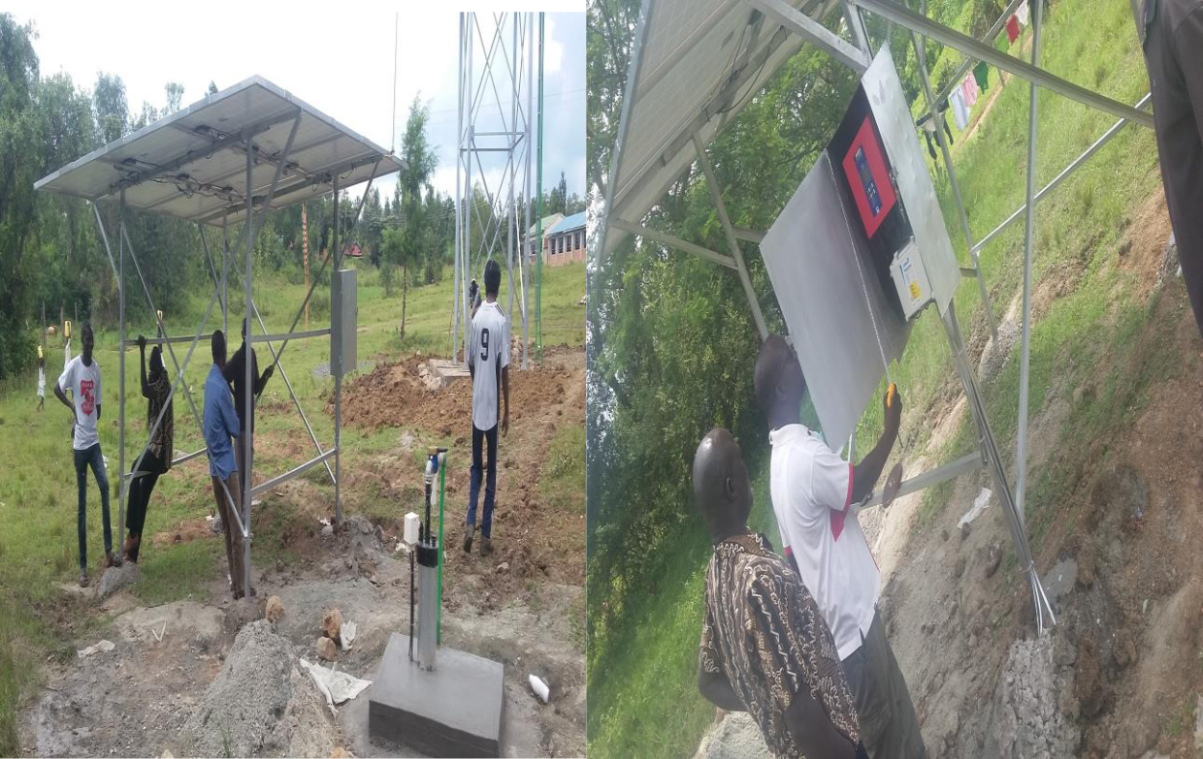

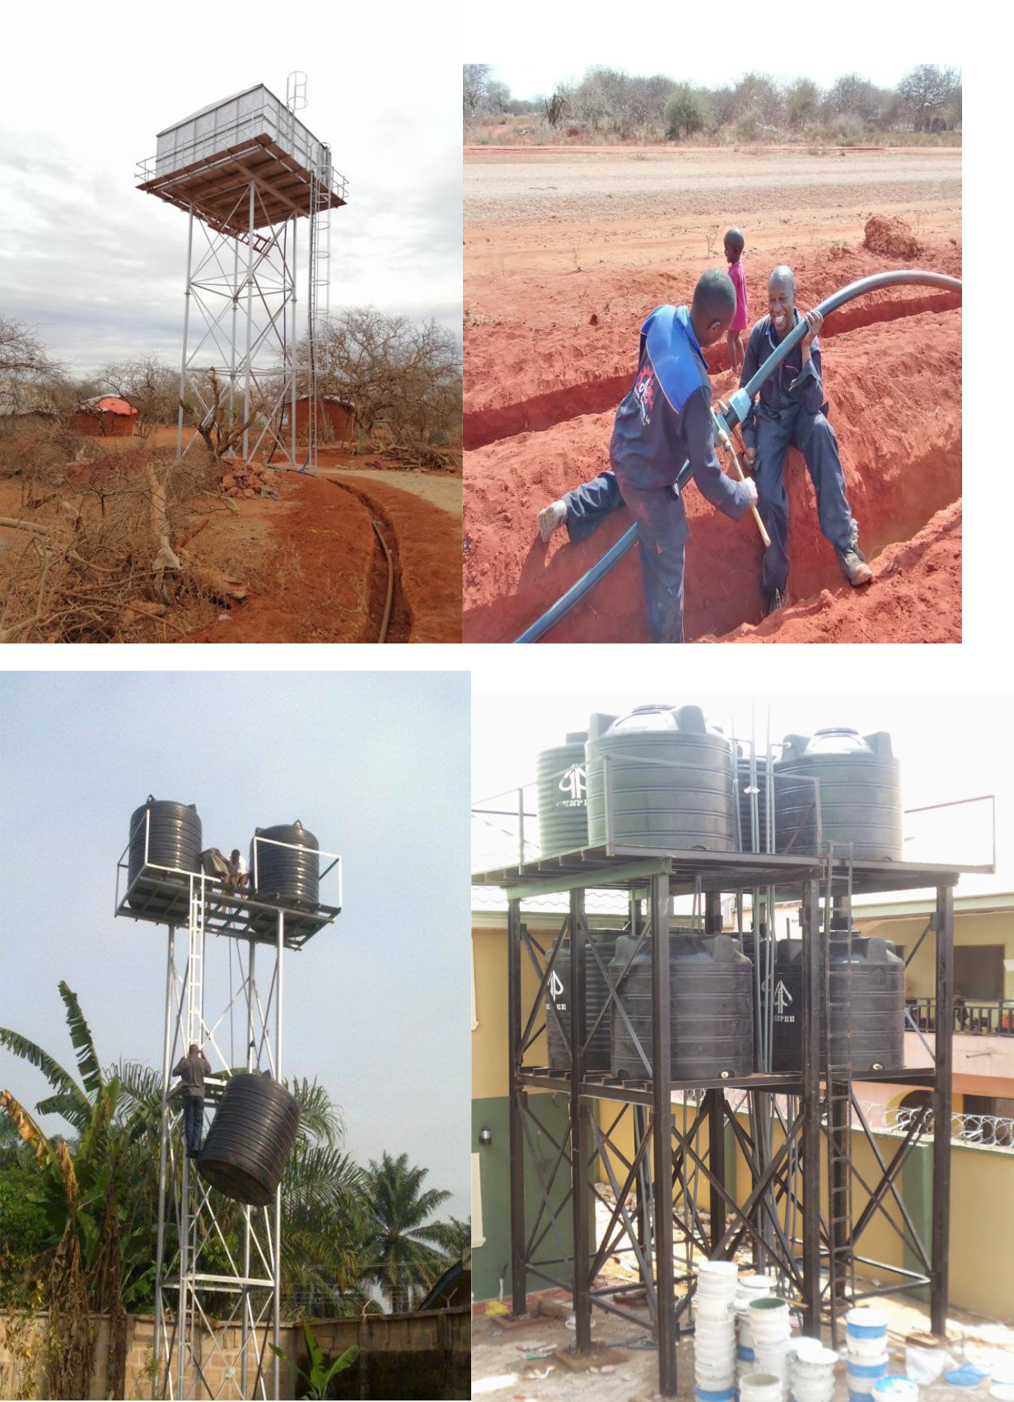

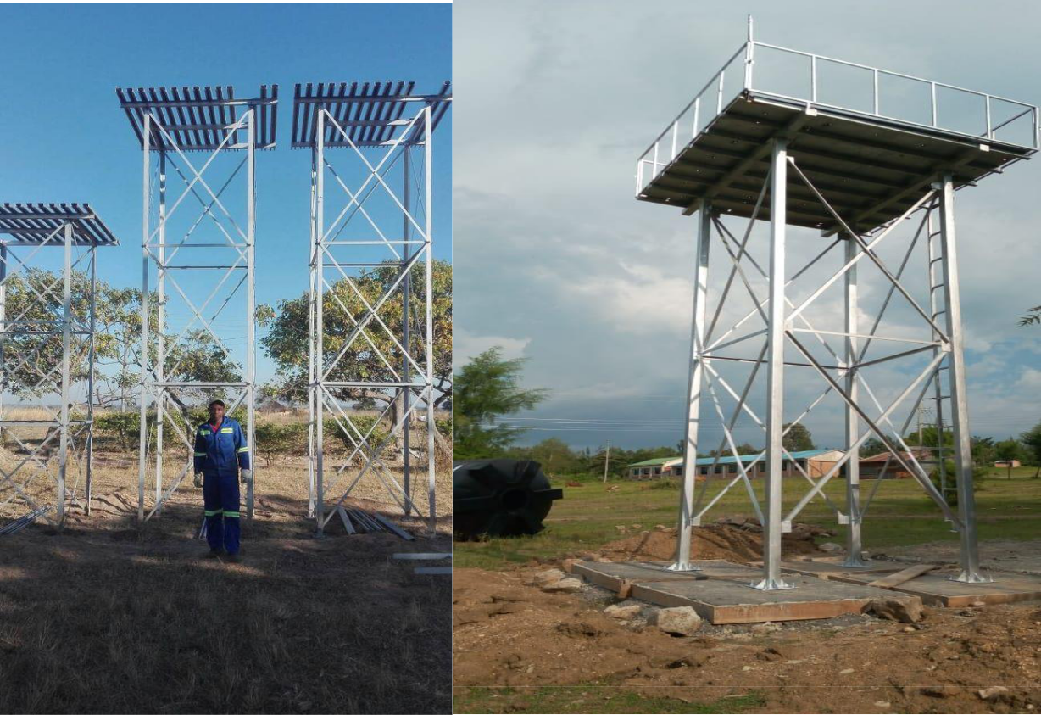

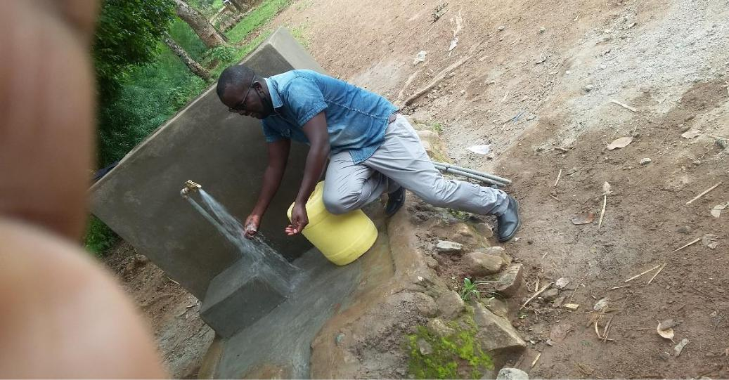

DRILLING EQUPMENTS

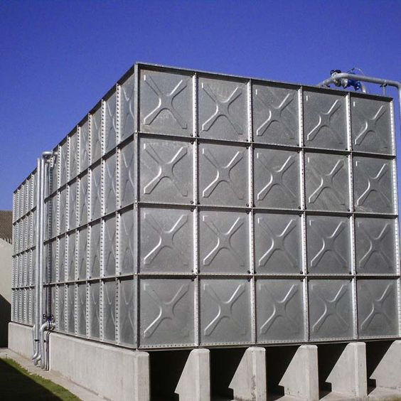

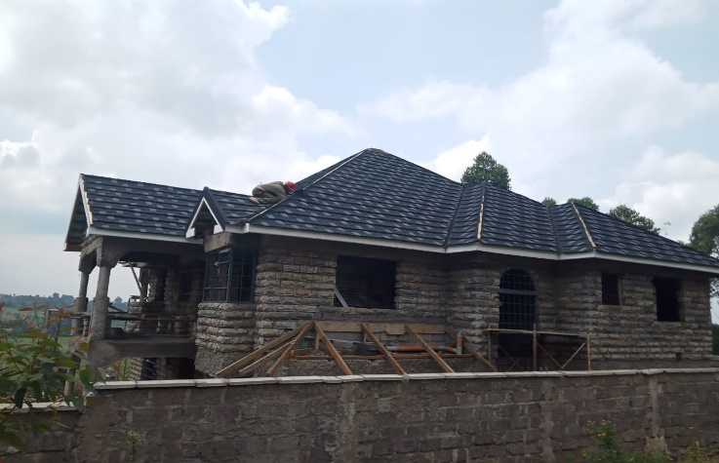

**A six-bedroom house in Kisumu; finishing ongoing**

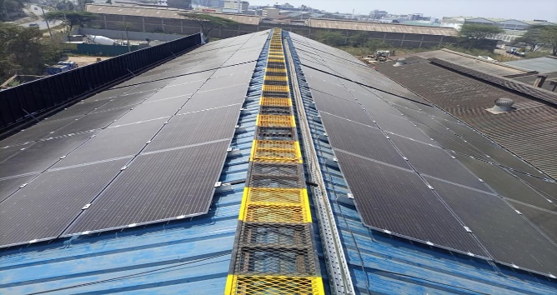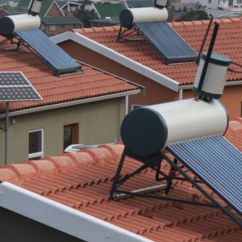

**(East Africa Spectra Ltd, Nairobi)**

**We get all you covered by installing state of the art CCTV system and manage them for you.**

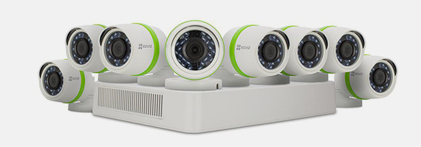

**Access Control System**

We install access control system to protect your company and equipment from any unauthorized /access. Building Access Systems can increase productivity and is particularly suitable for compliance. It may be structured to be automatic or to utilize a controller. It may offer free flow of traffic or require documentation by utilizing a system uses of tamper-proof credentials. They may be physical or digital, using key cards, pin cards or biometric scanners. Access codes via smart phone are also used. Most frequently, key or access cards are used to authenticate identity, especially for apartment security systems. Access Control may be supported by alarms and video surveillance. The more levels involved, the greater the management opportunities

**INSURANCE**

**WORKMAN’S COMPENSATION AND EMPLOYERS**

**LIABILITY (COMMON LAW) POLICY**

We are covered by **BRITAM** under the above policies and thus indemnified against liability in respect of any injury and against legal liability under common law for damages and claimant’s costs and expenses of litigation.

**7.1 LEGAL SERVICE PROVIDERS**

**Christabel Ashiono & Company Advocates**

PO Box 36-50100

Kakamega.

**7.2 AUDITORS**

Shadrack Nduri & Company

Certified Public Accountants

P.O Box 82044-80100

Mombasa

**PLANT AND EQUIPMENT AVAILABLE**

|  |  |  |  |  |  |
| --- | --- | --- | --- | --- | --- |
| **Equipment** | **Make/Model** | **Qty** | **Age**/year | **Status** | **Location** |
| Motor Vehicle | Tipper – 20Ton | 1 | - | Hire |  |
| “ | Canter - 7 Tons | 1 | - | owned |  |
| “ | Pick/Up –1Ton | 1 | - | “ |  |
| Conc. Mixer | 3.5 tons | 1 | - | “ |  |
| Hoist (portal) |  | 1 | - | “ |  |
| Poker vibrator |  | 1 | - | “ |  |
| Generator |  | 1 | 2 | owned | Kisumu yard |
| Plate compactor | 1.9 Tons | 1 | 1 | owned | “ |
| Wheel barrows |  | 4 | 1 | owned | “ |
| Assorted | Grinders, Drills | Item | 1 | owned | “ |
| Hand tools | Etc |  |  |  |  |
| Scaffolding |  | Item | - | Hire |  |
| Form work |  | Item | - | Hire |  |
|  |  |  |  |  |  |

**FIRM'S EXPERIENCE: RECENT BUILDING AND CIVIL WORKS PROJECTS**

|  |  |  |  |  |
| --- | --- | --- | --- | --- |
| **Project Name** | **Client & Contact** | **Nature of Work** | **Period/Year** | **Value of** |
| **Person** | **Contract** |
|  |  |  |
|  |  |  |  |  |
| Fabrication and Erection | Att: Mark Odoyo | SUBCONTRACT | YEAR | Kshs 1,120,000/- |
| of 2no. free-standing | (Dog trainer) | Kaime Builders ltd. | April. 2017 | Inclusive of VAT |
| steel kennels for | G4S security Ltd. | (Steel fabrication) |  |  |
| G4S security |  |  |  |  |
|  |  |  |  |  |
| House Repairs & Fencing | Attn: Margaret | CONTRACT | YEAR | Kshs 1,236,000.00 |
| in Nyali -Mombasa | Mwikali (Owner) | Renovation works | Feb. 2019 | Inclusive of VAT |
|  | Mombasa |  |  |  |
|  |  |  |  |  |
| Mantrap Access Control | Attn: Mr. V. Niaz | SUBCONTRACT | YEAR | Kshs 510,000.00 |
| at Links plaza – Nyali | (Projects Manager) | Shaphil Intl. Ltd. | June 2019 | Inclusive of VAT |
| Mombasa | Unilever (k) ltd. | (Security Installation) |  |  |
| Mombasa |  |  |  |
|  |  |  |  |
|  |  |  |  |  |
| Renovation of 2 Block | Attn: Mr. J. Mwacharo | SUBCONTRACT | YEAR | Kshs 1,490,700.00 |
| classroom | (Head teacher) | -Lisaka Trading Co. | Oct. 2019 | Inclusive of VAT |
| at Mwijo Primary school | Kilifi County | Renovation Works |  |  |
|  | Government |  |  |  |
|  |  |  |  |  |
| Erection of Market shade | Attn: Kepha Marube – | SUBCONTRACT | YEAR | Kshs |
| (phase 1) | (County Secretary) | -Lisaka Trading Co. | Aug. 2018 | 2,140,000.00 |
|  | Tana River County | (Steel fabrication) |  | Inclusive of VAT |
|  | Government |  |  |  |
|  |  |  |  |  |
| Painting & Ancillary | Att: | CONTRACT | YEAR | Kshs1, 360,000.00 |
| Works for KEMIA Building | Mr. Isaac Keya | Painting works | Feb. 2020 | Inclusive of VAT |
| At Gede - Malindi | (owner) |  |  |  |
|  | Kilifi County. |  |  |  |
|  |  |  |  |  |
| Garsen Water Projects | Min of water & sanitation | Drilling and distribution/water points construction 4 | 2019 | 5,000000, VAT Included |
| Kisumu county Government | Min of water & sanitation | contract for drilling of opande borehole water project ;TENDER No: CGK/W/KSM (SME)/2019-**2020/......** | 2020 | 3,500,000 |
|  |  | contract for equiping of kuoyo kowe water project  TENDER NO: CGK/W/KSM (SME)/2019-2020/006 |  |  |
|  |  |  |  |  |

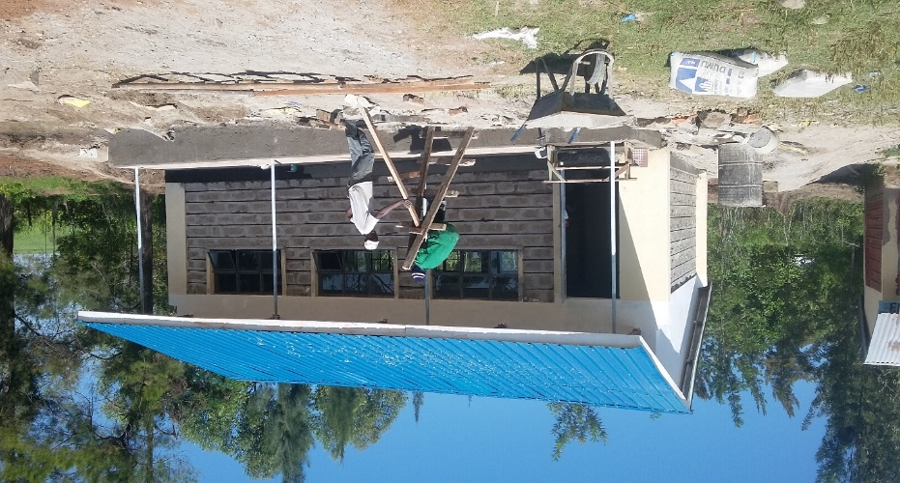

Construction of ECD Classroom; completed and handed over

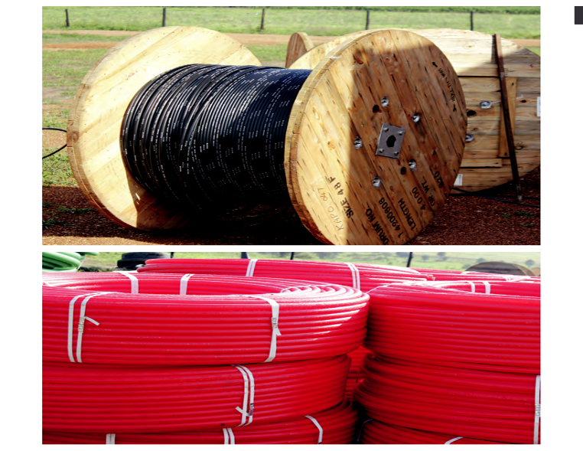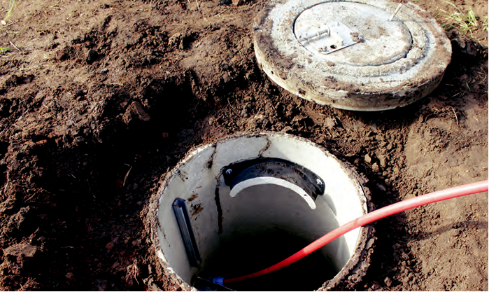**Telecommunication fibre optic installations**



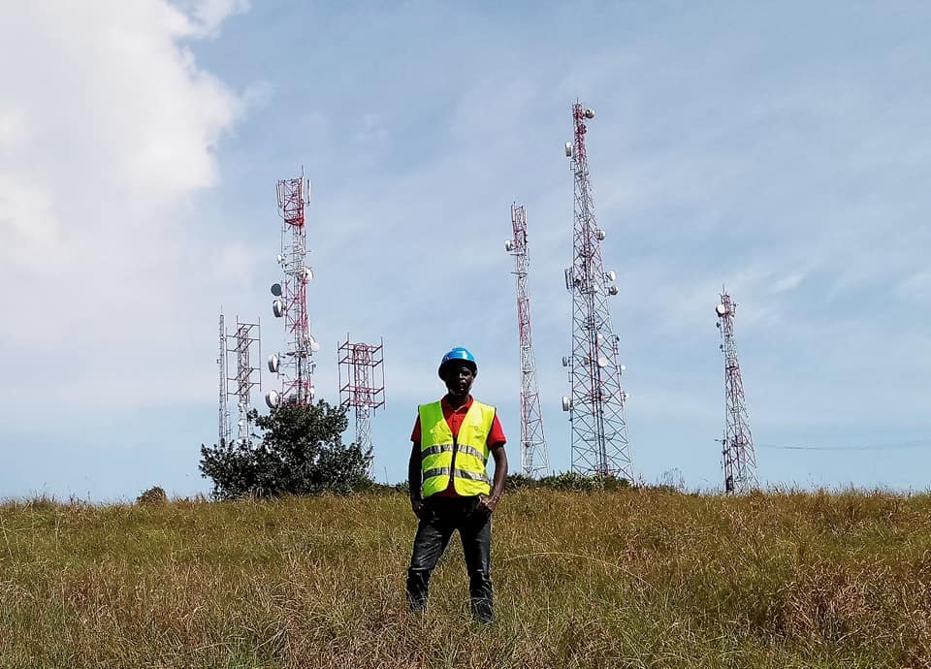

Eng. Vinn Kor posing for a photo after official handing over ceremony of the project

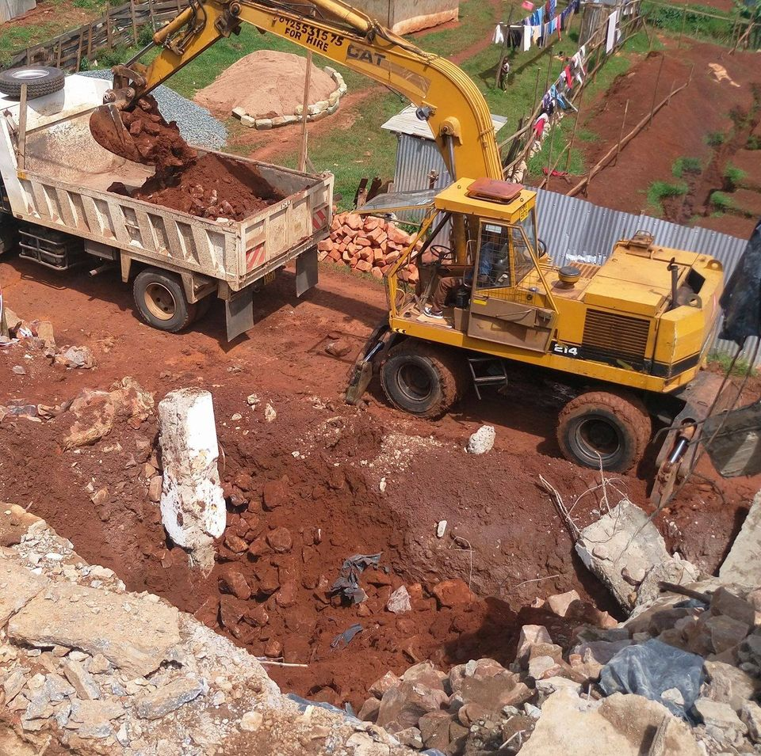

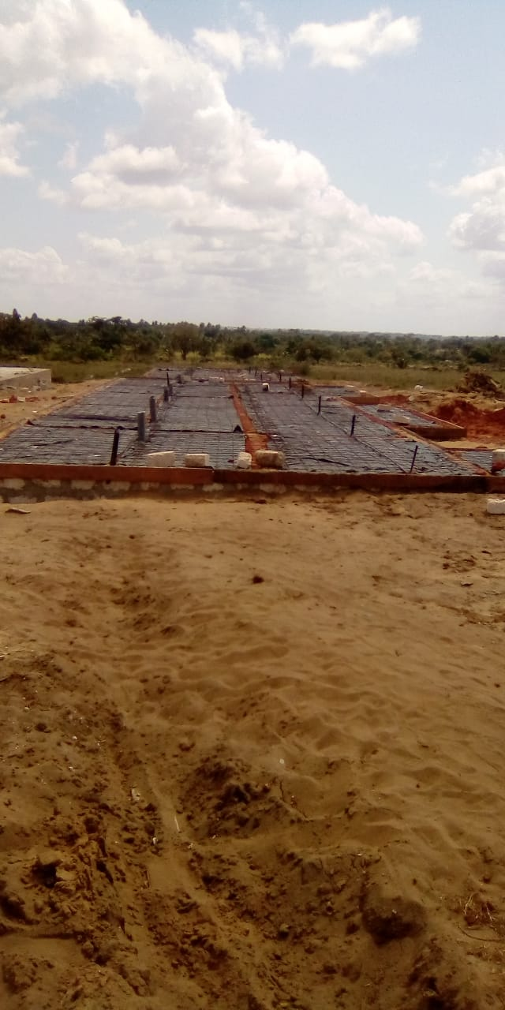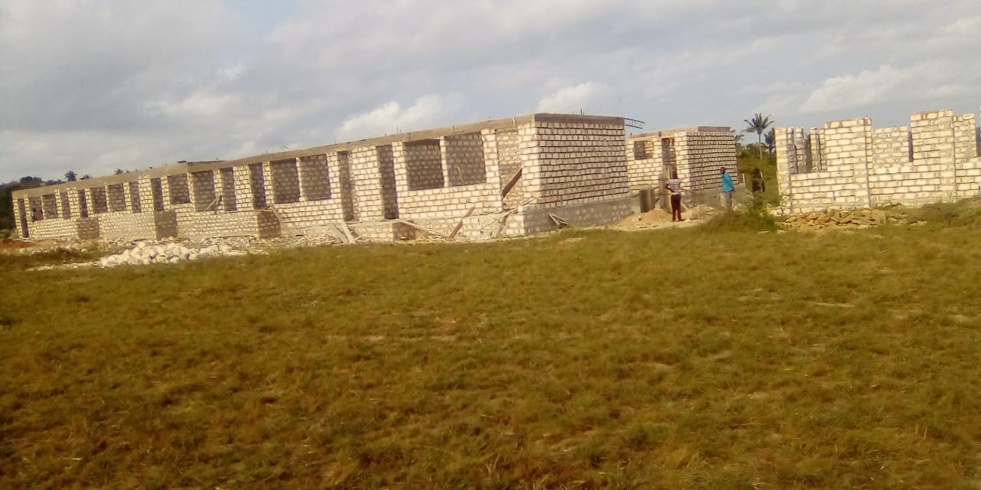

School construction underway in Kilifi County

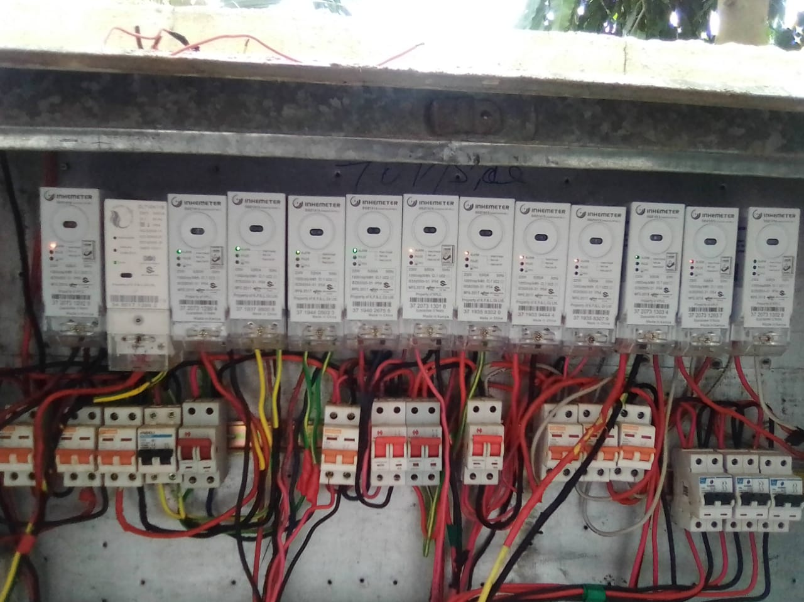

Apartment in Mombasa town completed with modern electrical fixation

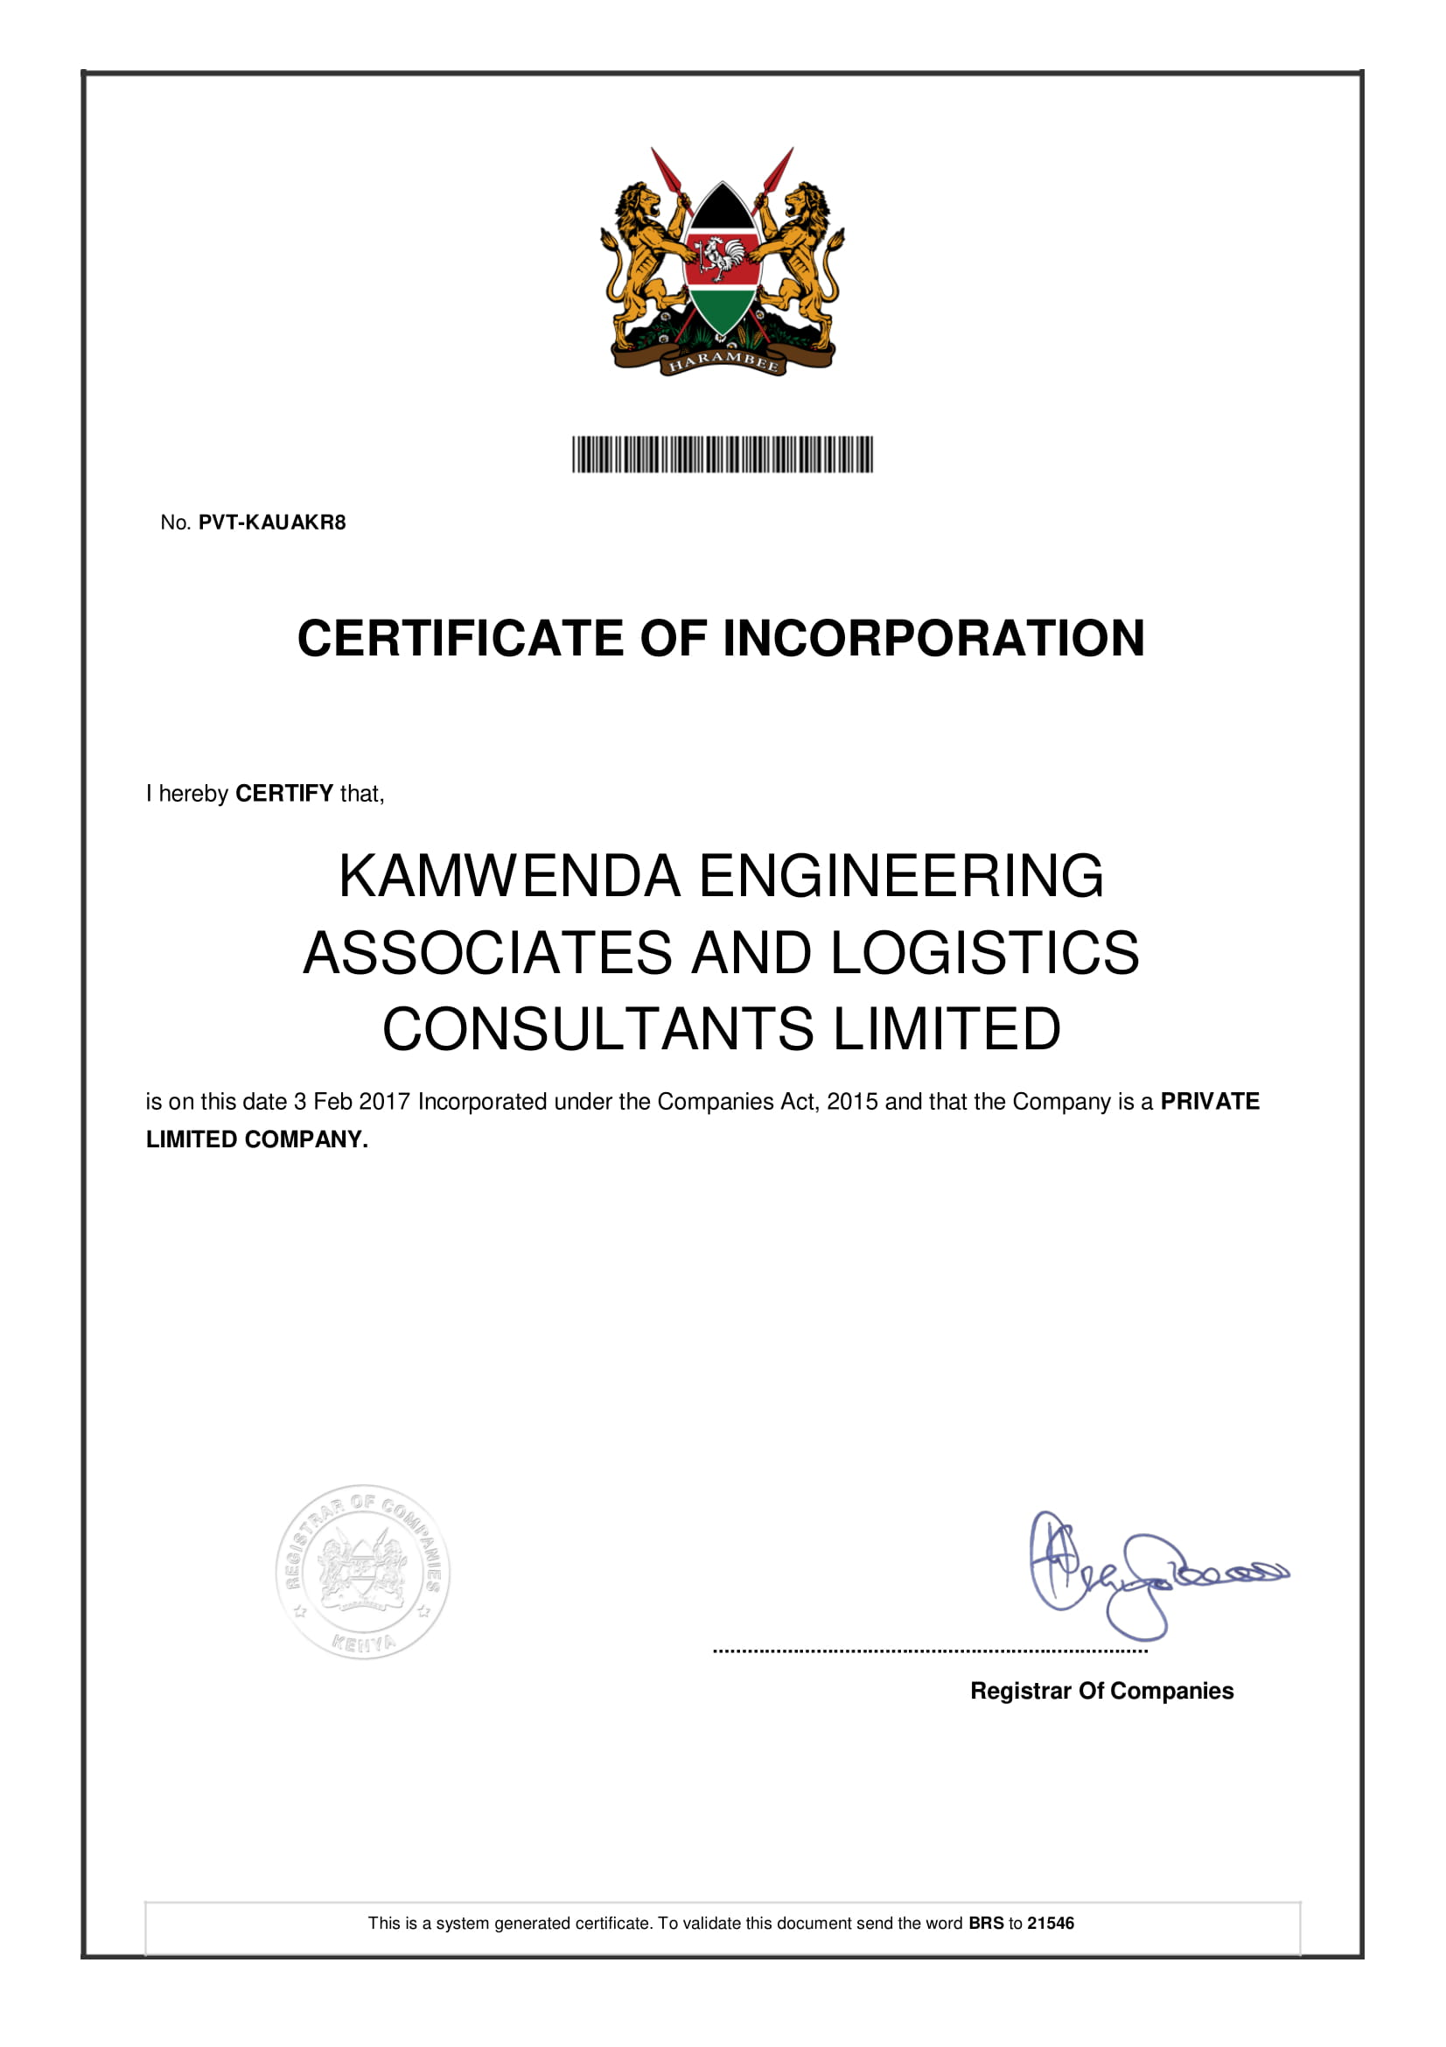

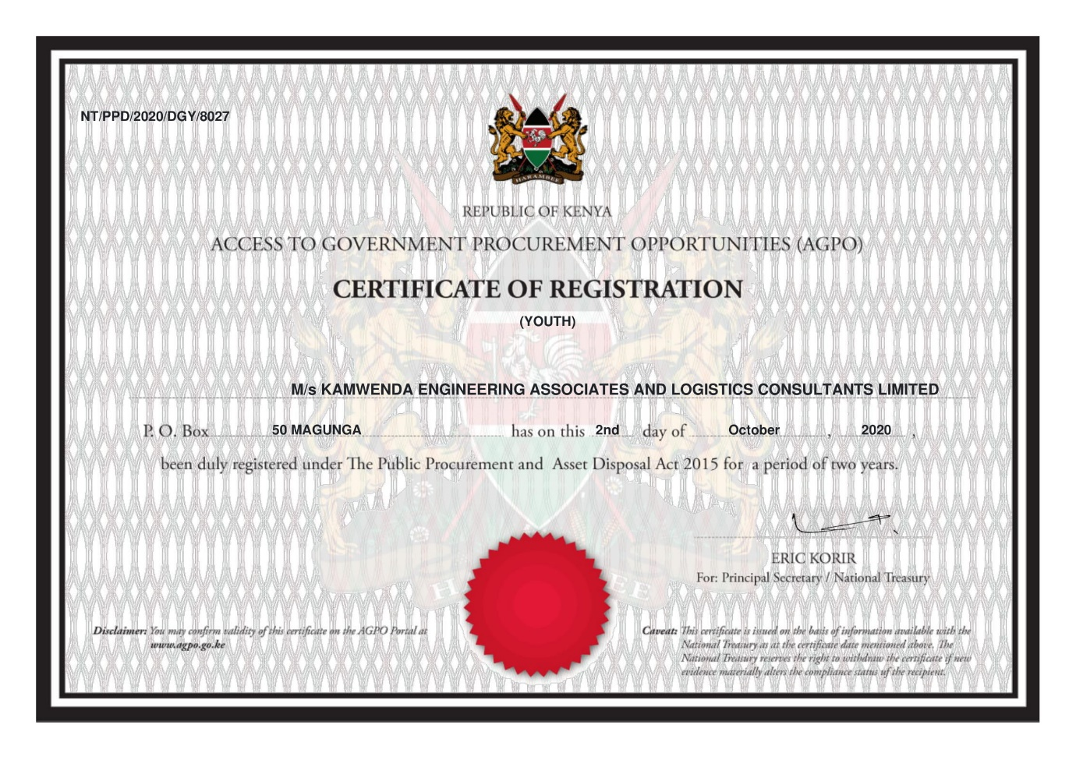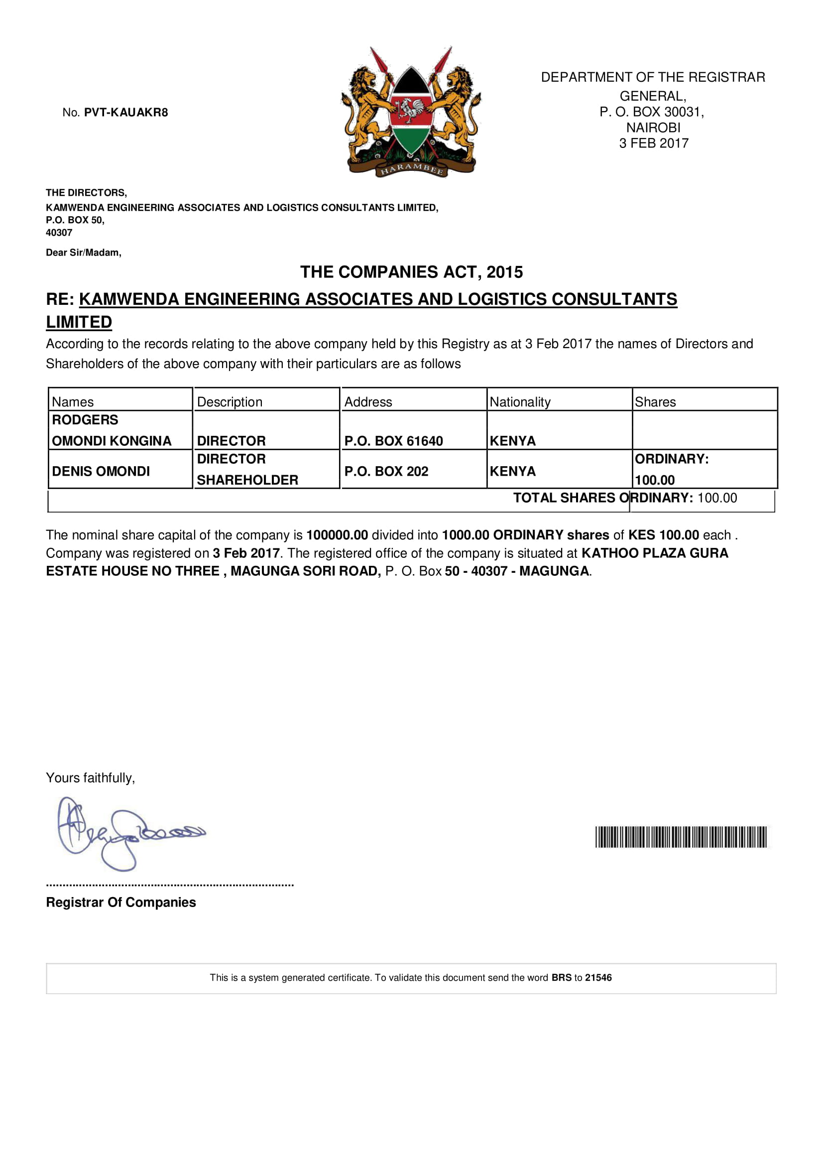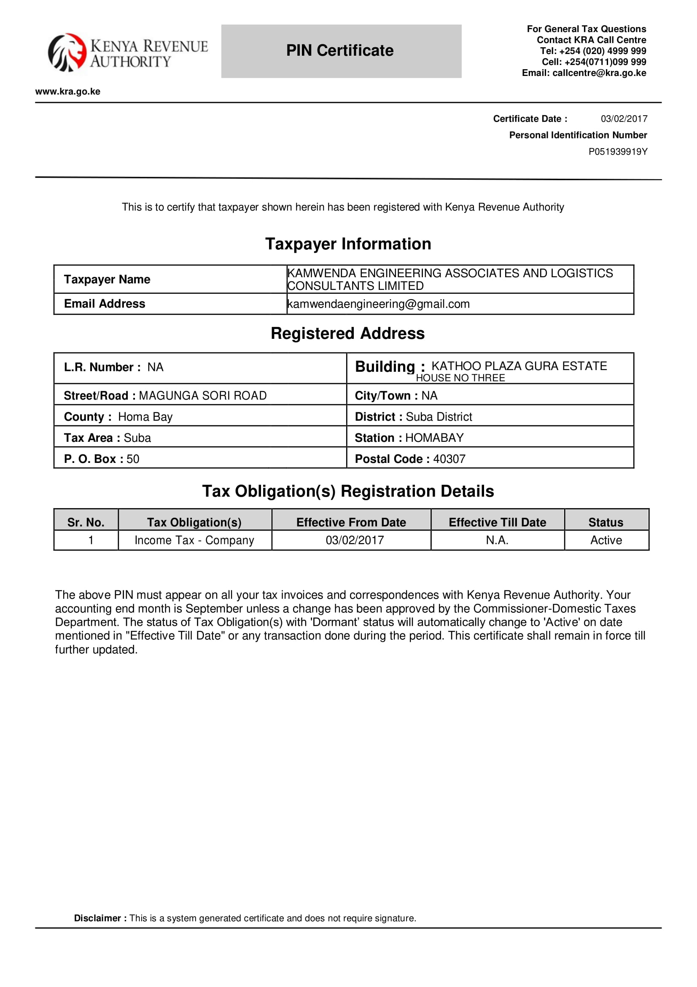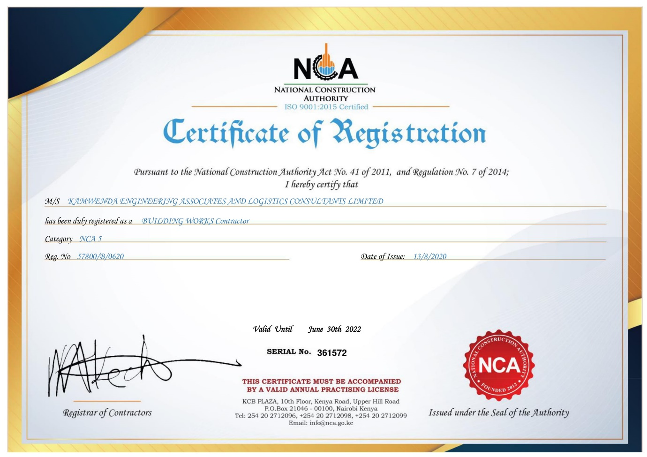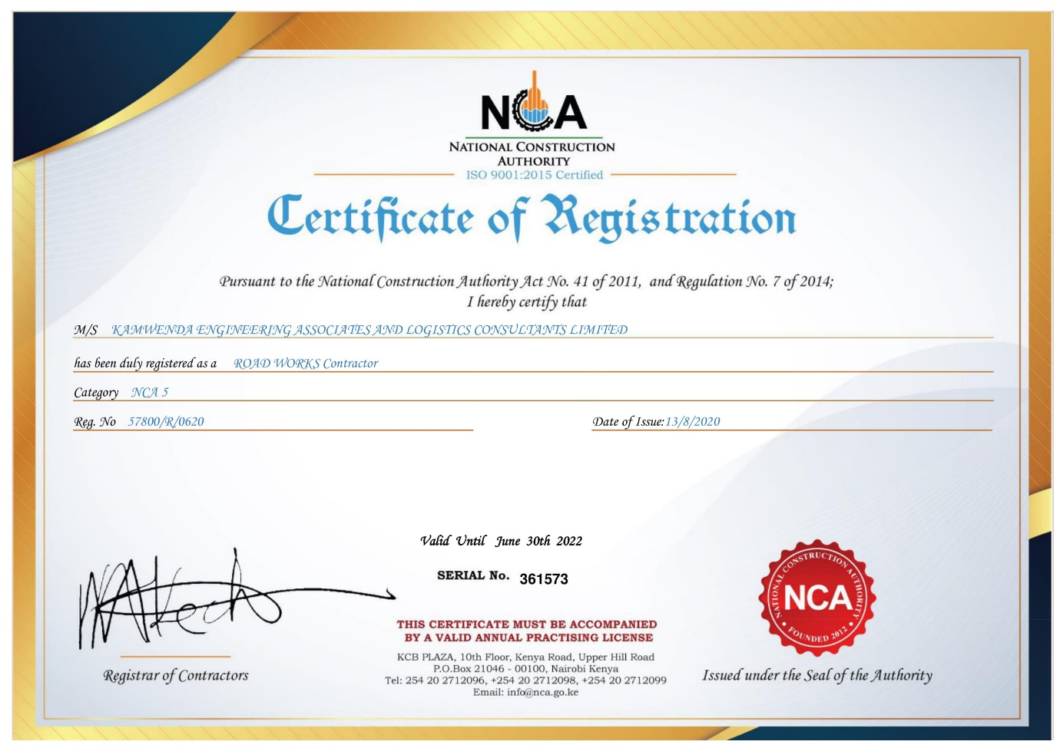z